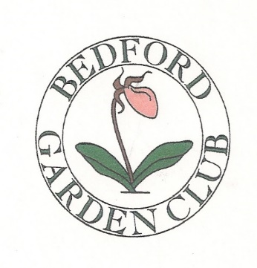

2016 Bedford Garden Club Fall Mum Sale

Order and Pre-pay by July 30, 2016 for early pick up
Tuesday September 6th, 1:00 – 6:00 pm
Bedford Farmers Market
190 Meetinghouse Road, St. Elizabeth Seton Church, Bedford, NH

Mums are priced at $8.00 each or $7.50 each for four or more plants
Mums are grown in NH and come in 10 inch pots
Possible colors are red, rust, yellow, lavender, and white
Color preference is not guaranteed

Name___________________________________________________________

Phone/Email______________________________________________________

# of Mums________________________________________________________

Payment_________________________________________________________

Preferred Colors___________________________________________________

Please Make Check Payable to: Bedford Garden Club
Send to:
Bedford Garden Club, Mum Sale
3 Meetinghouse Road
Bedford, NH 03110

