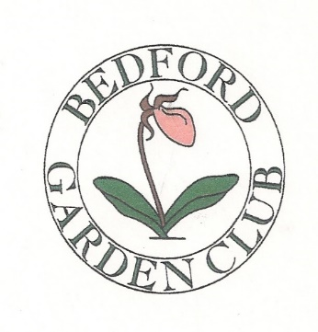

2018 Bedford Garden Club Fall Mum Sale

Order and Pre-pay by August 27, 2018 for early pick up
Tuesday September 4th, 1:00 – 6:00 pm
Bedford Farmers Market
190 Meetinghouse Road, St. Elizabeth Seton Church, Bedford, NH

Mums are priced at $7.50 each or 3 for $21.00
($7.00 each for three or more plants)
Mums are grown in NH and come in 8 inch pots
Possible colors are red, rust, yellow, lavender, and white
Color preference is not guaranteed

Name___________________________________________________________

Phone/Email______________________________________________________

# of Mums________________________________________________________

Payment_________________________________________________________

Preferred Colors___________________________________________________

Please Make Check Payable to: Bedford Garden Club
Send to:
Bedford Garden Club, Mum Sale
3 Meetinghouse Road
Bedford, NH 03110

